SECTION 1: Participant Information
Name: ___________________________________________________Date of Birth (mm/dd/yy): _____/_____/________
Address: ___________________________________________________________________________________________
City: ________________________________ State: _______________ Zip Code: ________________
E-mail address: ___________________________________________ Phone Number: ____________________________
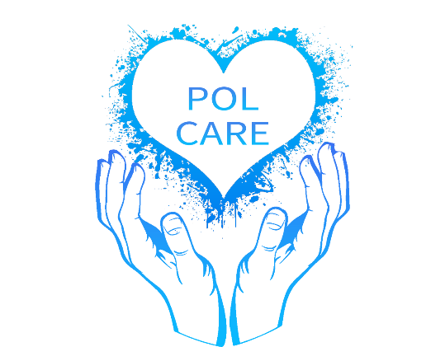
Current School: TISD Student: ____ TASD Student: ____ LISD Student ____ PGDSD ____ Red Lick ISD ______
SECTION 2: Allergies and Medications
Drug Allergies: ______________________________________________________________________________________
Food Allergies: ______________________________________________________________________________________
Current Medication(s): _______________________________________________________________________________
IF PARTICIPANT IS UNDER 18 YEARS OF AGE
PLEASE FILL OUT THE FOLLOWING

Parent/Guardian’s Name: _____________________________________________________________________________
Address (if different from above): ______________________________________________________________________
City/State/Zip (if different): ___________________________________________________________________________
Telephone #: (if different): ____________________________________________________________________________
Emergency Contact: _________________________________________________________________________________

HOLD HARMLESS RELEASE FORM
In consideration of being granted permission to enroll and participate in the POL CARE INC KIDZ Summer
Reading Program hosted by Texarkana College, along with related events and activities, the undersigned
hereby acknowledges, appreciates, and willingly agrees to the following terms and conditions:
1. Assumption of Risks: The undersigned recognizes that participation in the Summer Reading Program involves certain inherent risks. While POL CARE INC endeavors to create a safe and enjoyable environment, the undersigned understands that unforeseen circumstances may arise, resulting in potential injuries or accidents.
2. Acknowledgment of Responsibility: The undersigned acknowledges and willingly assumes full responsibility
for any risks, known or unknown, associated with the participant's involvement in the Summer Reading
Program.
3. Compliance with Program Policies: The undersigned agrees to ensure that the participant complies with all
stated rules, guidelines, and policies of the Summer Reading Program. Any observed hazards or concerns will
be promptly reported to the program organizers.
4. Health and Medical Considerations: The undersigned affirms that the participant is in good health and
capable of participating in the Summer Reading Program. Any known medical conditions or restrictions have
been disclosed to POL CARE INC.
5. Release and Hold Harmless Agreement: In consideration of the participant's enrollment in the Summer
Reading Program, the undersigned, on behalf of themselves and their heirs, assigns, personal representatives,
and next of kin, hereby releases and holds harmless POL CARE INC, Texarkana College, its officers, officials, agents, employees,
volunteers, and any affiliated entities, from any and all liability for personal injury, property damage, or any
other claims arising from the participant's involvement in the Program.
6. Exposure to Minor Illness: Recognizing the open nature of Texarkana College and the potential exposure to
minor illnesses such as influenza or cold, the undersigned assumes the associated risks willingly.
7. Emergency Medical Treatment Authorization: In the event of a medical emergency, the undersigned
authorizes POL CARE INC and its representatives to seek and consent to necessary medical treatment for the
participant.
8. Media Consent: The undersigned acknowledges that POL CARE INC may capture photographs, videos, or live footage during the Summer Kids Reading Program for promotional purposes. The undersigned grants full
consent and permission for the use of the participant's likeness in such materials, without any expectation of
compensation.
I HAVE READ THIS RELEASE OF LIABILITY AND ASSUMPTION OF RISK AGREEMENT, FULLY UNDERSTAND ITS TERMS, UNDERSTAND THAT I HAVE GIVEN UP SUBSTANTIAL RIGHTS BY SIGNING IT, AND SIGN IT FREELY AND VOLUNTARILY WITHOUT ANY INDUCEMENT.

PARTICIPANT (over 18): _______________________________________________________________DATE: ____________________

FOR PARTICIPANTS OF MINORITY AGE (Under 18)
This is to certify that I, as parent/guardian with legal responsibility for this participant, do consent and agree to his/her releasees as provided above of all the Releases, and for myself, my heirs, assigns, and next of kin, I release and agree to indemnify and hold harmless the Releasees from any and all liabilities incident to my minor child’s involvement or participation in these programs as provided above.

_________________________________________________________ _______________________________
Parent/Guardian Signature Date

